**HOUSE PRICE PREDICTION**

By

**NAVEEN KUMAR M-2015103519**

**UMAPATHI C -2015103613**

A Project report submitted to the

**FACULTY OF COMPUTER SCIENCE AND ENGINEERING**

For

**CREATIVE AND INNOVATIVE PROJECT**

In the academic year of 2018 - 2019



**DEPARTMENT OF COMPUTER SCIENCE AND ENGINEERING,**

**ANNA UNIVERSITY,**

**CHENNAI-25**

**ABSTRACT**

The Purpose of this project is to develop an application to predict the Sale price of the house. Since, due to the demand for Houses in recent times, there are a lot of real estate agents arises and tries to cheat the house holder by lowering there house value and try to sell the house to customer for high price and taking the difference amount as a agents commission. So an application which finds the actual price of a house is really very much useful in the field of Real Estate.

Here we building the Decision tree regression model and trained it using a collected data values from the city of boston. By using the high predictive power of Decision Tree model to predict the sale price of house from the user input values.

     Finally a Web application is designed to provide interface to the user for getting house attribute values and also to display the output sale price of a house.

**TABLE OF CONTENTS**

**ABSTRACT** 2

**1. INTRODUCTION** 5

1.1 Problem Domain 6

1.2 Significance 6

1.3 Problem Description 7

1.4 Swot Analysis 8

1.5 Pestel Analysis 9

1.6 Organization of Thesis 10

**2. RELATED WORK**

2.1 Decision Tree 11

2.2 Naive Bayes Classifier 11

2.3 Support Vector Machine 12

2.4 Random Forest 12

2.5 Observation from the Survey 13

**3. REQUIREMENT ANALYSIS**

3.1 Functional Requirements 15

3.2 Hardware Requirements 15

3.3 Constraints and Assumptions 16

**4. SYSTEM DESIGN**

4.1 System Architecture 18

4.2 UI Design 19

4.3 Class diagram 20

4.4 Module Design 20

4.5 Complexity Analysis 25

**5. SYSTEM DEVELOPMENT**

5.1 Prototype across a Modules 26

5.2 Algorithm 27

5.3 Deployment Details 28

**6. RESULTS AND DISCUSSION**

6.1 Dataset for Testing 29

6.2 Output Obtained in Various Stages 30

6.3 Sample Screenshots of various Input 33

**CHAPTER 1**

**INTRODUCTION**

In this project, we will evaluate the performance and predictive power of a model that has been trained and tested on data collected from homes in suburbs of Boston, Massachusetts. A model trained on this data that is seen as a good fit could then be used to make certain predictions about a home in particular, its monetary value. This model would prove to be invaluable for someone like a real estate agent who could make use of such information on a daily basis.

**1.1 PROBLEM DOMAIN**

In this project we have deployed Machine Learning to solve the Problem in Predicting the best selling price of the house. Now-a-day Machine learning providing us a way for lot of Complex Problem by Highly efficient Algorithms.

Therefore, we are also chosen Machine learning in solving the House Price Prediction Problem.

**1.2 SIGNIFICANCE**

Accurate real estate pricing is one of the key issues for countries all over the world. Firstly, at the microeconomic level, real estate, no matter it is a house or an apartment, is the most expensive expenditure that the majority of people will make during their lifetime. Current market housing prices may cause people to be misled by actions of sellers and other bidders, such as price manipulation and shill bidding.

What's more, accurate price models are also desired by real estate agents, whose objective is to sell houses both profitably and quickly. As it is unrealistic to achieve both goals to a high degree, they want to find a balance between profit and speed. A real estate pricing tool is of great help.

**1.3 PROBLEM DESCRIPTION**

Economists have long recognized that housing markets are geographically localized. Therefore, real estate market price indices are typically assumed to predict for certain geographic area within county area or metropolitan area, which only valid for that particular area. Another crucial issue of, real estate market differing with financial market is assumption of imperfections in real estate.  
There are many other methodologies to construct real estate market price indices except for hedonic regressions and repeat-sales analysis (Englund, Quigley and Red feam 1998; Case and Quigley 1991). However, hedonic and repeat-sales models are the fundamental of all other evolution models.  
 Unfortunately, Both of these two models have their own flaws. Since the hedonic regression model uses data on a vector of key characteristics to control property quality, this method needs large amounts of data across different periods. Since the selected properties must be transacted at least twice, those properties sold only once must be discarded from the sample, which exclude the majority of transactions data.   
 There fore, it fails to utilize the full information in real estate market, which may affect the results. To the best of my knowledge, regression model, especially regularized regression model has not been performed in real estate data analysis up to now, even though it has been well developed by previous studies and been implemented in other scientific and empirical fields. Regression models, one of the most powerful tools in statistics, focus on learning the relationship among multiple variables statistically by coming up a functional relationship between two or more features such that the feature that people care mostly can be predicted from the other or the others.   
 As mentioned above, the scientific goal here is to achieve accurate enough predictions of median property price of tracts basing upon all approachable features, so regression model in statistics science is one of the most reasonable solvents for this problem.

**1.4 SWOT ANALYSIS**

**SWOT** Analysis is a planning tool used to understand the Strength, Weakness, Opportunities, and Threats involved in a project. It involves specifying the objective of the project and identifying the internal and external factors that are supportive or unfavourable to achieving that objective.  
 **S**: Play to your Strength  
 **W**: Address Weaknesses  
 **O**: Exploit Opportunities

**T**: Hedge against Threats

**S: Strength**

Our project will help to the new house sellers and buyers to easily knowing their house real value. This works as an advantage to the agents and they manipulate the price and increase their own profits.  
 Our Project will predict a stable reasonable Price of the house. We use feature selection technique so it will give importance to the key features of the house.  
  
**W: Weakness**

There are various other factors in the market that affect the prices. Parameters like Economy, the inflation rate of an area may result in increase or decrease in the prices.  
 The features are not sufficient anymore, in real time we have to take more features like salaries, demand, population into consideration.

**O: Opportunities**

“House Price Prediction” will have opportunities in the country. There are lot of employment in our India. For eradicate the Unemployment problem only solution is self-employment. Government policies like the Real Estate Regulatory

Authority (RERA) have influenced fresh buyer condense into the real estate sector.

**T: Threats**

People mindset will always changing, so we predict Sometimes, a model is either too complex or too simple to sufficiently generalize to new data.  
 . Other times, the data itself could be too noisy or contain too few samples to allow a model to adequately capture the target variable -i.e., the model is underfitted.

**1.5 PESTEL ANALYSIS**

A **PESTEL** analysis is a framework or tool used by marketers to analyze and monitor the macro-environmental (external marketing environment) factors that have an impact on an organization. The result of which is used to identify threats and weaknesses which is used in a SWOT analysis.

PESTEL stands for:

**P: Political** Political interventions will be reduced because of digitalization.

**E: Economic** Buying and selling the Real estate properties will increase the tax amount which leads to the increase of Country’s Economy.

**S: Social** It will reduce the intermediate person (agents).So the buyer need not to give any extra amounts.

**T: Technological** It increases the Digitalization of the Society. It paves way for Technological development of the county.

**E: Environmental** The application will also analyze the environmental features, so the environmental variables also taken consideration.

**L: Legal** It will give a good upto date market of the price for each house. So the correct income tax of the house will be paid by buyer.

**1.6 ORGANISATION OF THESIS**

Chapter 2 discuss the existing approaches to House Price Prediction in greater detail. Chapter 3 gives the requirement analysis of the system. It explains the functional and nonfunctional requirements, constraints and assumptions made in the implementation of the system.

**CHAPTER 2**

**RELATED WORK**

This gives a survey of various machine learning that can be designed for House price prediction. The models include the likes of decision Tree, SVM, Naive Bayes, Random Forest. This helped to us study in details the various methods and choice the best which suits our needs.

**2.1 DECISION TREE**

Decision Tree algorithm belongs to the family of [supervised learning algorithms](https://dataaspirant.com/2014/09/19/supervised-and-unsupervised-learning/). Unlike other supervised learning algorithms, decision tree algorithm can be used for solving [regression and classification](https://dataaspirant.com/2014/09/27/classification-and-prediction/) problems too.

The general motive of using Decision Tree is to create a training model which can use to predict class or value of target variables by learning decision rules inferred from prior data (training data).

The understanding level of Decision Trees algorithm is so easy compared with other classification algorithms. The decision tree algorithm tries to solve the problem, by using tree representation. Each internal node of the tree corresponds to an attribute, and each leaf node corresponds to a class label.

**2.2 NAIVE BAYES CLASSIFIER**

In [machine learning](https://en.wikipedia.org/wiki/Machine_learning), naive Bayes classifiers are a family of simple "[probabilistic classifiers](https://en.wikipedia.org/wiki/Probabilistic_classifier)" based on applying [Bayes' theorem](https://en.wikipedia.org/wiki/Bayes%27_theorem) with strong (naive) [independence](https://en.wikipedia.org/wiki/Statistical_independence) assumptions between the features. It remains a popular (baseline) method for [text categorization](https://en.wikipedia.org/wiki/Text_categorization), the problem of judging documents as belonging to one category or the other (such as [spam or legitimate](https://en.wikipedia.org/wiki/Spam_filtering), sports or politics, etc.) with [word frequencies](https://en.wikipedia.org/wiki/Bag_of_words) as the features. With appropriate pre-processing, it is competitive in this domain with more advanced methods including [support vector machines](https://en.wikipedia.org/wiki/Support_vector_machine). It also finds application in automatic [medical diagnosis](https://en.wikipedia.org/wiki/Medical_diagnosis).

**2.3 SUPPORT VECTOR MACHINE**

“Support Vector Machine” (SVM) is a supervised machine learning algorithm which can be used for both classification or regression challenges. However, it is mostly used in classification problems. In this algorithm, we plot each data item as a point in n-dimensional space (where n is number of features you have) with the value of each feature being the value of a particular coordinate. Then, we perform classification by finding the hyper-plane that differentiate the two classes very well (look at the below snapshot).

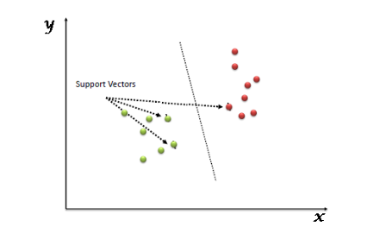

Support Vectors are simply the co-ordinates of individual observation. Support Vector Machine is a frontier which best segregates the two classes (hyper-plane/ line).

**2.4 RANDOM FOREST**

Random forest is like bootstrapping algorithm with Decision tree (CART) model. Say, we have 1000 observation in the complete population with 10 variables. Random forest tries to build multiple CART model with different sample and different initial variables. For instance, it will take a random sample of 100 observation and 5 randomly chosen initial variables to build a CART model. It will repeat the process (say) 10 times and then make a final prediction on each observation. Final prediction is a function of each prediction. This final prediction can simply be the mean of each prediction.

**2.5 OBSERVATIONS FROM THE SURVEY**

We propose to use Decision Tree Model. Since, One big advantage of the [decision tree model](https://www.brighthubpm.com/resource-management/96340-sample-of-a-decision-making-tree/) is its transparent nature. Unlike other decision-making models, the decision tree makes explicit all possible alternatives and traces each alternative to its conclusion in a single view, allowing for easy comparison among the various alternatives. The use of separate nodes to denote user defined decisions, uncertainties, and end of process lends further clarity and transparency to the decision-making process.

A major decision tree analysis advantages is its ability to assign specific values to problem, decisions, and outcomes of each decision. This reduces [ambiguity in decision-making](https://www.brighthubpm.com/resource-management/98724-potential-flaws-of-group-decision-making-processes/). Every possible scenario from a decision finds representation by a clear fork and node, enabling viewing all possible solutions clearly in a single view. Incorporation of monetary values to decision trees help make explicit the costs and benefits of different alternative courses of action. A decision tree is the best predictive model. It finds use to make [quantitative analysis of business problems](http://www.brighthub.com/office/project-management/articles/48360.aspx), and to validate results of statistical tests. It naturally supports classification problems with more than two classes and by modification, handles regression problems.

Sophisticated decision tree models implemented using custom software applications can use historic data to apply a statistical analysis and make predictions regarding the probability of events. For instance, the decision tree analysis helps to improve the decision-making capability of commercial banks by assigning success and failure probability on application data to identify borrowers who do not meet the traditional, minimum-standard criteria set for borrowers, but who are statistically less likely to default than applicants who meet all minimum requirements.

Decision trees provide a framework to quantify the values and probability of each possible outcome of a decision, allowing decision makers to make educated choices among the various alternatives.

**CHAPTER 3**

**REQUIREMENT ANALYSIS**

**3.1 FUNCTIONAL REQUIREMENTS**

The Developed System outputs a Median value of the sales price of a house. The output prediction should adhere to the following requirements:

* The Predicted value should be reasonable depending on the feature of the house
* The error rate of the prediction shouldn’t be larger.
* The Model should be stable when the size of the dataset is modified
* More reliable estimate of out-of-sample performance than train/test split should achieved
* The Model must taken higher consideration for the key features of a house
* The system must be optimized for space complexity.
* The system must be able to make prediction based on the entered input value.
* Server response time must be optimal.

**3.2 NON FUNCTIONAL REQUIREMENTS**

**3.2.1 USER INTERFACE**

There must be a simple and easy to use user interface where the user should view his outputs and graphical structures.

**3.2.2 HARDWARE REQUIREMENTS**

The client side requirement is only a browser with good internet connection. The server side must be able to handle multiple requests & tools to run machine learning python scripts. Server must be able to run javascript runtime environment (NodeJS).

**3.2.3 SOFTWARE REQUIREMENTS**

* OS-Windows, Linux or Mac.
* Programming Languages -JavaScript, Python.
* Frameworks - Jquery, Bootstrap.
* Libraries - Pandas, Scikit-learn, Numpy.
* Tools-Anaconda.

**3.3 CONSTRAINTS AND ASSUMPTIONS**

**3.3.1 CONSTRAINTS**

* Data collected from a rural city may not be applicable as the demographics would change and other features may be better able to fit the dataset instead of a model with features that was learned using urban data.
* The learning algorithm learned from a very old dataset that may not be relevant because demographics have changed a lot since 1978.
* There are only 3 features currently, there are more features that can be included such as crime rates, nearby to city, public transport access and more.

**3.3.2 ASSUMPTIONS**

* The input dataset is assumed that it contains all the key features of the house.
* The data is assumed that is doesn’t undergoes underfitting.
* The input dataset does not have any invalid symbols and characters.

**CHAPTER 4**

**SYSTEM DESIGN**

**4.1 SYSTEM ARCHITECTURE**

The block diagram of the entire system in shown in figure below. A web application has been developed and its description are explained in section 4.2.

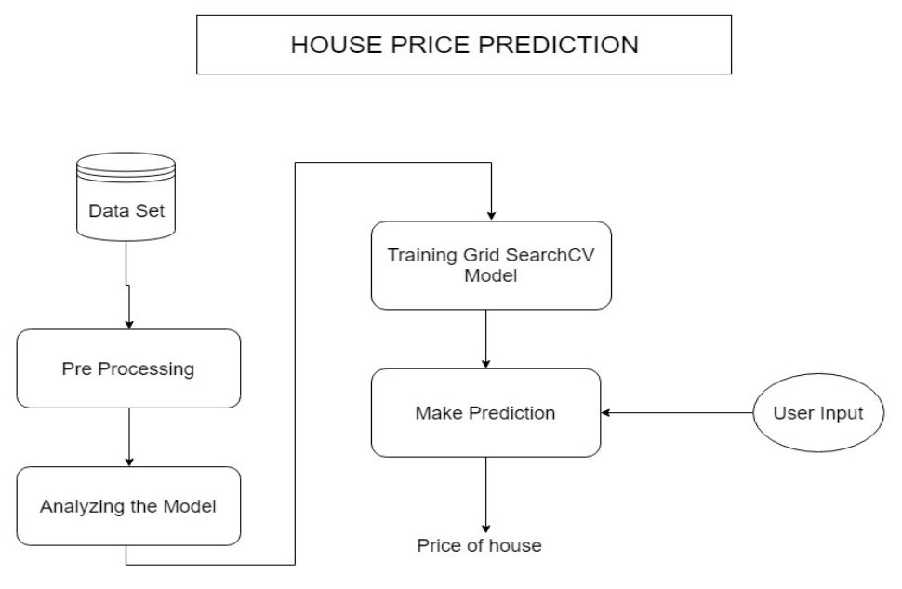

**Figure 4.1** System Architecture

**4.2 UI DESIGN**

HTML and Bootstrap are used to develop the front end. The Graphical user interface, is a type of user interface that allows user to interact with electronic devices through graphical icons and visual indicators such as secondary notation, instead of text-based user interfaces, typed command labels or text navigation. Nearly all digital interfaces are GUIs.

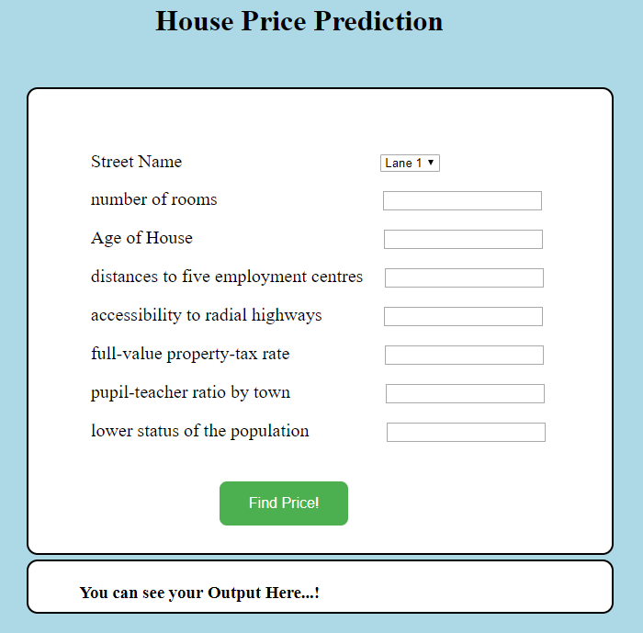

**Figure 4.2** UI Screenshot

**4.3 CLASS DIAGRAM**

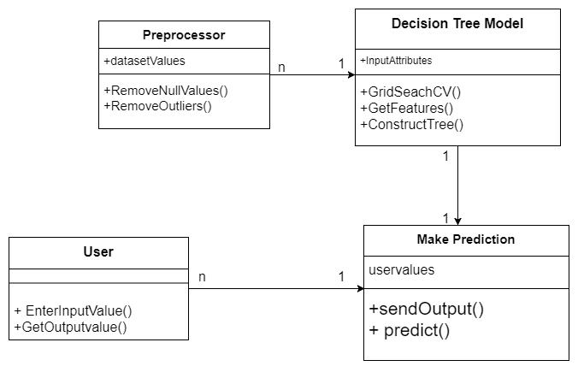

**Figure 4.3** Class Diagram

**4.4 MODULE DESIGN**

**4.4.1 PRE PROCESSING**

Data preprocessing is a data mining technique that involves transforming raw data into an understandable format. Real world data is often incomplete, inconsistent, and/ or lacking in certain behavior or trends, and is likely to contain many errors. Data preprocessing is a proven method of resolving such issues.

* **Data cleaning:** fill in missing values, smooth noisy data and resolve inconsistencies.
* **Data Transformation:** normalization and aggregation.
* **Data Reduction:** reducing the volume but producing the same or similar analytical results.
* **Data discretization:** part of data reduction, removing numerical attributes and special characters.

We will make a cursory investigation about the Boston housing data and provide our observations. Familiarizing ourself with the data through an explorative process is a fundamental practice to help you better understand and justify your results.

**Figure 4.1** Data Exploration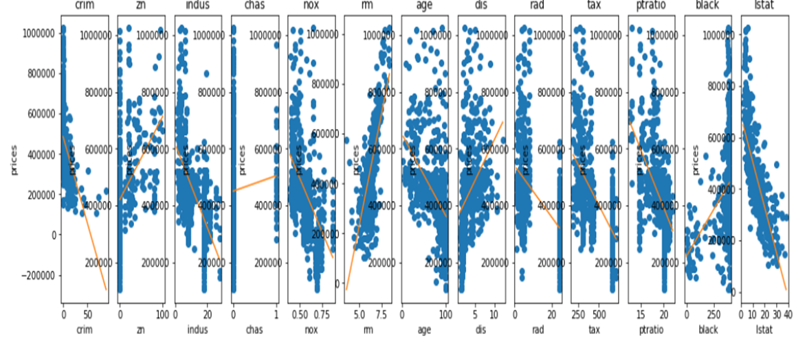

**4.4.2 ANALYZING THE MODEL**

In this section, we'll take a look at several models' learning and testing performances on various subsets of training data. Additionally, you'll investigate one particular algorithm with an increasing 'max_depth' parameter on the full training set to observe how model complexity affects performance. Graphing your model's performance based on varying criteria can be beneficial in the analysis process, such as visualizing behavior that may not have been apparent from the results alone.

### **Grid SearchCV**

In essence, the grid search technique allows one to define a grid of parameters that will be searched using K-fold cross-validation. Importantly, the grid search technique exhaustively tries every combination of the provided hyper-parameter values in order to find the best model. One can then find the highest cross-validation accuracy that matches with the corresponding parameters that optimizes the learning algorithm.

we'll take a look at several models' learning and testing performances on various subsets of training data. Additionally, we'll investigate one particular algorithm with an increasing 'max_depth' parameter on the full training set to observe how model complexity affects performance. Graphing our model's performance based on varying criteria can be beneficial in the analysis process, such as visualizing behavior that may not have been apparent from the results alone.

**Learning Curves**

The following code cell produces four graphs for a decision tree model with different maximum depths. Each graph visualizes the learning curves of the model for both training and testing as the size of the training set is increased. Note that the shaded region of a learning curve denotes the uncertainty of that curve (measured as the standard deviation). The model is scored on both the training and testing sets using R2, the coefficient of determination.

**Complexity Curves**

The following code cell produces a graph for a decision tree model that has been trained and validated on the training data using different maximum depths. The graph produces two complexity curves — one for training and one for validation. Similar to the learning curves, the shaded regions of both the complexity curves denote the uncertainty in those curves, and the model is scored on both the training and validation sets using the performance_metric function.

**4.4.3 MODEL TRAINING**

To ensure that you are producing an optimized model, we will train the model using the grid search technique to optimize the 'max_depth' parameter for the decision tree. The 'max_depth'parameter can be thought of as how many questions the decision tree algorithm is allowed to ask about the data before making a prediction. Decision trees are part of a class of algorithms called supervised learning algorithms.

For the fit_model function in the code cell below, we will need to implement the following:

Use [DecisionTreeRegressor](http://scikit-learn.org/stable/modules/generated/sklearn.tree.DecisionTreeRegressor.html) from sklearn.tree to create a decision tree regressor object. Create a dictionary for 'max_depth' with the values from 1 to 10, and assign this to the 'params' variable.Create a scoring function object. Use [GridSearchCV](http://scikit-learn.org/stable/modules/generated/sklearn.grid_search.GridSearchCV.html) from sklearn.grid_search to create a grid search object.

**4.4.4 MAKING PREDICTION:**

Our model has been trained on a given set of data, it can now be used to make predictions on new sets of input data. In the case of a decision tree regressor, the model has learned what the best questions to ask about the input data are, and can respond with a prediction for the target variable. You can use these predictions to gain information about data where the value of the target variable is unknown — such as data the model was not trained on.

Imagine that you were a real estate agent in the Boston area looking to use this model to help price homes owned by your clients that they wish to sell. You have collected the following information from your clients:

1. per capita crime rate by town(CRIM)
2. proportion of residential land zoned for lots over 25,000 sq.ft.(ZN)
3. proportion of non-retail business acres per town.(INDUS)
4. Charles River dummy variable (1 if tract bounds river; 0 otherwise)(CHAS)
5. nitric oxides concentration (parts per 10 million)(NOX)
6. average number of rooms per dwelling(RM)
7. proportion of owner-occupied units built prior to 1940(AGE)
8. weighted distances to five Boston employment centres(DIS)
9. index of accessibility to radial highways(RAD)

10. full-value property-tax rate per $10,000(TAX)

11. pupil-teacher ratio by town(PTRATIO)

12. % of lower status of the population(LSTAT)

By giving these informations as a input to the trained model. Our Model will predict the Median value of house i.e.,. Sale price of the house.

**4.5 COMPLEXITY ANALYSIS**

**4.5.1 TIME COMPLEXITY**

The time complexity of all preprocessing steps in O(N).

In case of Decision Tree the depth of a tree is O (logn), where n is the number of rows of data and the tree is assumed to be relatively balanced. For each of the splits in the tree, you will need to test every feature for all values to determine the value split that minimizes the loss function.

Assuming number of features is m, the run time is O (mnlogn).

**4.5.2 COMPLEXITY OF THE PROJECT**

Data collected from a rural city may not be applicable as the demographics would change and other features may be better able to fit the dataset instead of a model with features that was learned using urban data.  
 The learning algorithm learned from a very old dataset that may not be relevant because demographics have changed a lot since 1978.  
 There are only 3 features currently, there are more features that can be included such as crime rates, nearby to city, public transport access and more.

**CHAPTER 5**

**SYSTEM DEVELOPMENT**

**5.1 PROTOTYPE ACROSS THE MODULES**

The input and output to each module of the system is described in the section.

**5.1.1 PREPROCESSOR**

This module takes the house specifications like no of rooms, area, crime rate etc… as input and produces as intermediary output the text without special characters and numbers. This is followed by tokenizing the text and removing stop words. A bag of words approach is used. The countvectorizer produces the bag of words.

**5.1.2 ANALYZING THE MODEL**

This module takes the preprocessed data as a input and uses the attributes like Features (all features except the target variable) and Prices(target variable). It produces the learning curves for model and Complexity curve for overall model to explore the best parameter. This uses matplotlib for drawing curves.

**5.1.3 TRAINING THE MODEL**

This module takes the data which we split as a Train and Test. It uses the Train dataset as a input an gives the optimal Trained model as a output. Use [DecisionTreeRegressor](http://scikit-learn.org/stable/modules/generated/sklearn.tree.DecisionTreeRegressor.html) from sklearn.tree to create a decision tree regressor object.

**5.1.4 MAKE PREDICTION**

This is our Final module which takes the user given values as a input and predict the best sale price of the house by fitting the input values to our model and shows as the output value as a sale price of a house.

**5.2 ALGORITHM**

The **GridSearch CV** algorithm used for predict the House Price is shown below

*def gridsearch(loop):  
 param_opt = []  
 alpha_opt = []  
 l1_ratio_opt = []  
 for x in range(loop):  
 n_splits = 10 #the number of groups  
 k_fold = KFold(n_splits=n_splits, shuffle=True) #make dataset random  
 rmse_10 = []  
 intercept = []  
 alpha = [0.1, 0.5, 1.0, 10]  
 l1_ratio = [0.1, 0.2, 0.3, 0.4, 0.5, 0.6, 0.7, 0.8, 0.9, 1.0]  
 best_score = 100  
 for i in alpha:  
 for j in l1_ratio:  
 clf = linear_model.ElasticNet (alpha = i, l1_ratio = j)  
 for train_index, test_index in k_fold.split(X): #check the overfitting  
 X_train = X[train_index]  
 y_train = y[train_index]  
 X_test = X[test_index]  
 y_test = y[test_index]  
 fit = clf.fit(X_train, y_train)  
 y_pred = clf.predict(X_test)  
 rmse_10.append(mean_squared_error(y_test, y_pred)**0.5)  
 rmse_mean = np.mean(rmse_10)  
 rmse_10 = []  
 if rmse_mean < best_score:  
 best_score = rmse_mean  
 best_alpha = i  
 best_l1_ratio = j  
 param_opt.append([best_alpha, best_l1_ratio])  
 alpha_opt.append(best_alpha)  
 l1_ratio_opt.append(best_l1_ratio)  
 df_alpha = pd.DataFrame({'alpha' : alpha_opt})  
 df_l1_ratio = pd.DataFrame({'l1' : l1_ratio_opt})  
 df_param = pd.concat([df_alpha, df_l1_ratio],axis=1)   
 df_param = df_param.groupby(['alpha','l1']).size().sort_values(ascending=False).reset_index(name='size')  
 alpha = df_param.iloc[0, 0]  
 l1_ratio = df_param.iloc[0, 1]  
 return alpha, l1_ratio, df_param*

**5.3** **DEPLOYMENT DETAILS**

Python libraries such as Pandas, numpy, sklearn, etc… must be available in the deployment environment with support to deploy NodeJS application. Apart from these front end libraries such as bootstrap and jquery must be made available either locally made in server or through CDN.

CHAPTER 6

**RESULTS AND DISCUSSION**

**6.1 DATASET FOR TESTING**

The Housing Dataset consists of price of houses in various places in Boston. Alongside with price, the dataset also provide information such as Crime (CRIM), areas of non-retail business in the town (INDUS), the age of people who own the house (AGE) etc…

However, because we are going to use scikit-learn, we can import it right away from the scikit-learn itself. We will use several python libraries as required here.

**6.1.1** **DATASET NAMING**

* CRIM - per capita crime rate by town
* ZN - proportion of residential land zoned for lots over 25,000 sq.ft.
* INDUS - proportion of non-retail business acres per town.
* CHAS - Charles River dummy variable (1 if tract bounds river; 0 otherwise)
* NOX - nitric oxides concentration (parts per 10 million)
* RM - average number of rooms per dwelling
* AGE - proportion of owner-occupied units built prior to 1940
* DIS - weighted distances to five Boston employment centres
* RAD - index of accessibility to radial highway.
* 10.TAX - full-value property-tax rate per $10,000
* PTRATIO - pupil-teacher ratio by town
* B - 1000(Bk - 0.63)^2 where Bk is the proportion of blacks by town
* LSTAT - % lower status of the population
* MEDV - Median value of owner-occupied ho mes in $1000's

**6.2 OUTPUT OBTAINED IN VARIOUS STAGES**

This section shows the results obtained during module testing.

**6.2.1 INPUT**

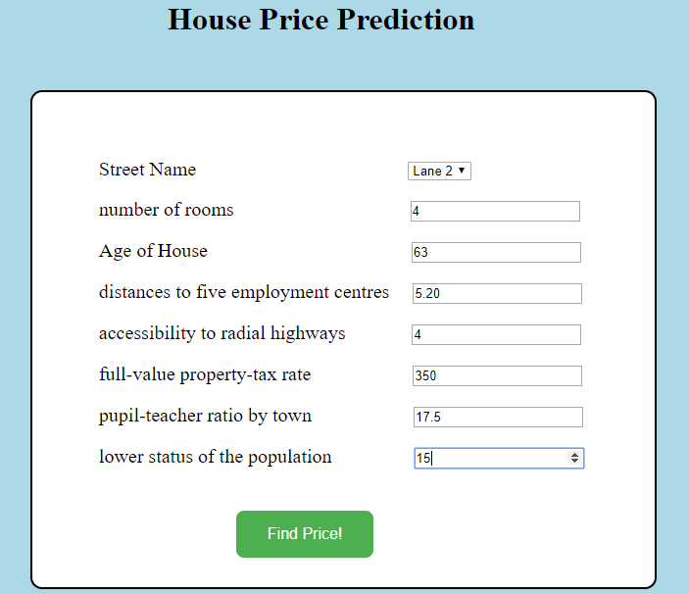

**Figure 6.1** Sample Input

**6.2.2 MODEL ANALYSING**

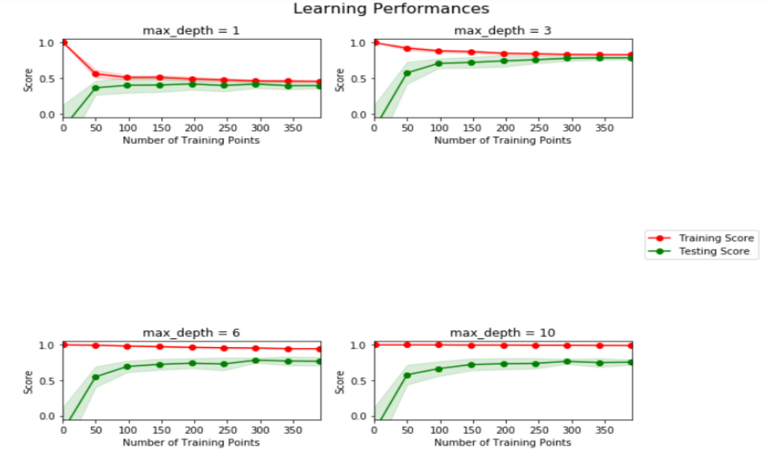

**Figure 6.2** Model Analyzing

**6.2.3 PRICE PREDICTION**



**Figure 6.3** Price Prediction

**6.2.4 MODEL TRAINING**

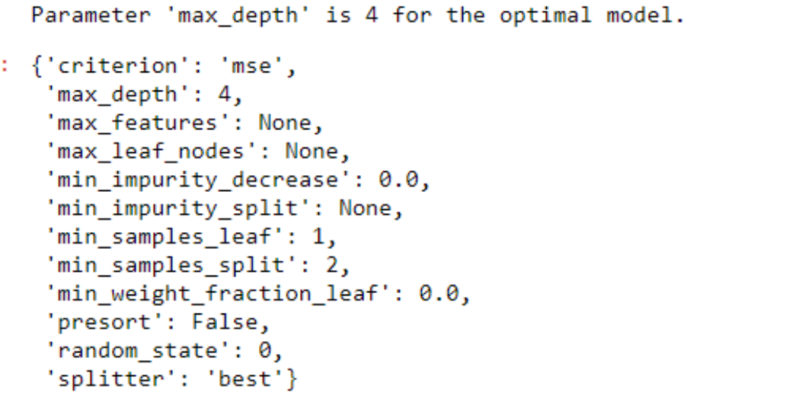

**Figure 6.4** Model Training

**6.3 SAMPLE SCREENSHOTS DURING TESTING**

**6.3.1 INPUT**



**Figure 6.5** Sample Input

**6.3.2 OUTPUT **

**Figure 6.6** Sample Output